

Grace House School

First Aid Policy

Signed by:

Sam Thomas Senior Headteacher Date: September 2025
Cerasela Raducanescu | Education Director | Date: | September 2025
Natalie Moore | Regional Head  Teacher/ALNCO | Date: | September 2025

Review Date: September 2026

Contents
1. Aims 3
2. Roles and responsibilities 3-3
3. First aid procedures 4-4
4. First aid equipment 5
5. Record-keeping and reporting 5-6
6. Training 6
7. Monitoring arrangements 6
8. Links with other policies 7
9.Nearest hospital……………………………………………………………………………………….7
Appendix 1: list of first aiders 8
Appendix 2: accident report form 9
Appendix 3: first aid training log 10

………………………………………………………………………………………………………………………

Aims
The aims of our first aid policy are to:
- Ensure the health and safety of all staff, pupils, and visitors.
- Ensure that staff and the proprietor are aware of their responsibilities with regards to health and safety
- Provide a framework for responding to an incident and recording and reporting the outcomes.

Roles and responsibilities

2.1 Appointed person(s) and first aiders
The school’s appointed persons are the Senior Headteacher and the Home Manager; however, most staff will have completed First Aid training.
The Senior Headteacher and the Home Manager will be responsible for:
- Taking charge when someone is injured or becomes ill.
- Ensuring there is an adequate supply of medical materials in first aid kits and replenishing the contents of these kits.
- Ensuring that an ambulance or other professional medical help is summoned when appropriate.
The Senior Headteacher and the Home Manager are trained and qualified to carry out the role (see section 7) and are responsible for the following:
- Acting as first responders to any incidents, they will assess the situation where there is an injured or ill person and provide immediate and appropriate treatment.
- Sending pupils home to recover, where necessary
- Filling in an accident report on the same day, or as soon as is reasonably practicable, after an incident (see the template in appendix 2)
- Keeping their contact details up to date
Our school’s first aiders are listed in appendix 1. Their names will also be displayed prominently around the school.

2.2 Health & Safety Officer
The health & safety officer Sheraz Rattoo has ultimate responsibility for health and safety matters in the school, but delegates operational matters and day-to-day tasks to the Senior Headteacher and staff members.

2.3 The Senior Headteacher
The Senior Headteacher is responsible for the implementation of this policy, including:
- Ensuring that an appropriate number of trained first aid personnel are present in the school at all times.
- Ensuring that first aiders have an appropriate qualification, keep training up to date and remain competent to perform their role.
- Ensuring all staff are aware of first aid procedures.
- Ensuring appropriate risk assessments are completed, and appropriate measures are put in place.
- Undertaking, or ensuring that staff undertake, risk assessments, as appropriate, and that appropriate measures are put in place.
- Ensuring that adequate space is available for catering to the medical needs of pupils.
- Reporting specified incidents to the HSE when necessary (see section 6)

2.4 Staff
School staff is responsible for:
- Ensuring they follow first aid procedures.
- Ensuring they know who the first aiders in school are.
- Completing accident reports (see appendix 2) for all incidents they attend to where a first aider is not called.
- Informing the Senior Headteacher or their manager of any specific health conditions or first aid needs

First aid procedures
3.1 In-school procedures
In the event of an accident resulting in injury:
- The closest member of staff present will assess the seriousness of the injury and seek the assistance of a qualified first aider, if appropriate, who will provide the required first aid treatment.
- The first aider, if called, will assess the injury, and decide if further assistance is needed from a colleague or the emergency services. They will remain on scene until help arrives.
- If an individual is requiring a defibrillator, CPR, fallen from a high, has a suspected back injury or is excessively bleeding especially from a head injury, ears or vomiting blood then you must ring an ambulance. This is not an exhausted list and an ambulance can be phoned for a wide range of other situations as referenced in the bullet point above.
- The first aider will also decide whether the injured person should be moved or placed in a recovery position.
- If the first aider judges that a pupil is too unwell to remain in school, parents/carers will be contacted and asked to collect their child. Upon their arrival, the first aider will recommend the next steps to the parents/carers.
- If emergency services are called, the Senior Headteacher will contact parents immediately.
- The first aider/relevant member of staff will complete an accident report form on the same day or as soon as is reasonably practical after an incident resulting in an injury and email to Health & Safety Officer Sheraz Rattoo, homes manager and social worker.
- Bodily fluids of all types must be treated as infectious, and these will be cleaned using appropriate equipment (bathroom mop and bucket and blue roll) and PPE. All PPE and other equipment that cannot be sterilised to be binned in its own bin bag and put immediately into the outside general waste bin.

3.2 Off-site procedures
When taking pupils off the school premises, staff will ensure they always have the
following:
- A school mobile phone
- A portable first aid kit
- Information about the specific medical needs of pupils
- Parents/Carers contact details.
Risk assessments will be completed, and public liability requested by the Senior Headteacher prior to any educational visit that necessitates taking pupils off school premises.
There will always be at least one first aider on school trips and visits.

First aid equipment
A typical first aid kit in our school will include the following:
- A leaflet with general first aid advice
- Regular and large bandages
- Eye pad bandages
- Triangular bandages
- Adhesive tape
- Disposable gloves
- Antiseptic wipes
- Plasters of assorted sizes (anti-allergenic)
- Scissors
- Cold compresses
- Burns dressings.
No medication is kept in first aid kits.
First aid kits are stored in:
- The medical room
- The school classrooms
- School vehicles

Record-keeping and reporting
5.1 First aid and accident record book
- An accident form will be completed by the first aider/relevant member of staff on the same day or as soon as possible after an incident resulting in an injury.
- As much detail as possible should be supplied when reporting an accident, including all of the information included in the accident form at appendix 2
- A copy of the accident report form will also be added to the pupil’s educational record by the Senior Headteacher.
- Records held in the first aid and accident book will be retained by the school for a minimum of 3 years, in accordance with regulation 25 of the Social Security (Claims and Payments) Regulations 1979, and then securely disposed of.

5.2 Reporting to the HSE
The Health & Safety Officer will keep a record of any accident which results in a reportable
injury, disease, or dangerous occurrence, as defined in the RIDDOR 2013 legislation
(regulations 4, 5, 6 and 7).
The Health & Safety Officer Sheraz Rattoo will report these to the Health and Safety
Executive as soon as is reasonably practicable and in any event within ten days of the
incident.
Reportable injuries, diseases or dangerous occurrences include:
- Death
- Specified injuries, which are:
  - Fractures, other than to fingers, thumbs, and toes
  - Amputations
  - Any injury likely to lead to permanent loss of sight or reduction in sight.
  - Any crush injury to the head or torso causing damage to the brain or internal organs.
  - Serious burns (including scalding)
  - Any scalping requiring hospital treatment.
  - Any loss of consciousness caused by head injury or asphyxia.
  - Any other injury arising from working in an enclosed space which leads to hypothermia or heat-induced illness or requires resuscitation or admittance to hospital for more than 24 hours.
- Injuries where an employee is away from work or unable to perform their normal work
duties for more than seven consecutive days (not including the day of the incident)
- Where an accident leads to someone being taken to hospital
- Near-miss events that do not result in an injury but could have done. Examples of
near-miss events relevant to schools include, but are not limited to:
  - The accidental release or escape of any substance that may cause a serious injury or damage to health.
  - An electrical short circuit or overload causing a fire or explosion.
Information on how to make a RIDDOR report is available here:
How to make a RIDDOR report, HSE
http://www.hse.gov.uk/riddor/report.htm

Training
All school staff will undertake first aid training.
All first aiders must have completed a training course and must hold a valid certificate of competence to show this. The school will keep a register of all trained first aiders, what training they have received, and when this is valid until (see appendix 3).
Staff are encouraged to renew their first aid training when it is no longer valid.

Monitoring arrangements
This policy will be reviewed by the Senior Headteacher every year and particularly after any
changes, to ensure the provision is adequate.
At every review, the policy will be approved by the Education Director and Regional Head
Teacher.

Links with other policies
This first aid policy is linked to the
- Health and safety policy
- Risk assessment policy

- Hospital

Royal Shrewsbury Hospital,
Mytton Oak Rd,
Shrewsbury,
SY3 8XQ
01743 261000

Minor Injuries Only.
Victoria Ward Memorial minor injury unit,
Salop Rd,
Welshpool
SY2 7DU
- 558900

10.Nearest defibrillator
Priest Weston, Village Hall, Montgomery, SY15 6DE 2.1 miles
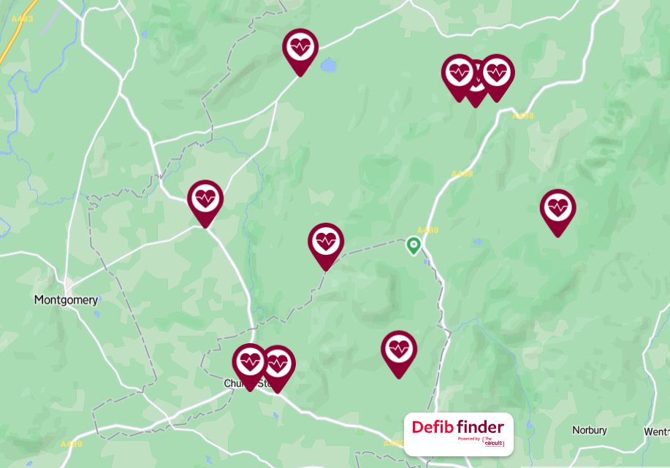
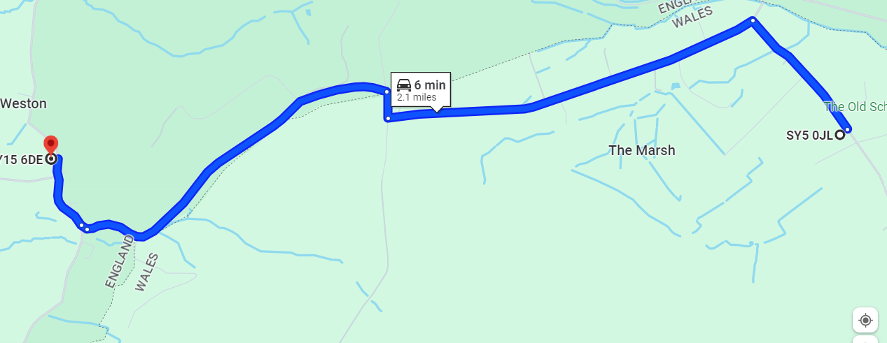

Appendix 1: list of trained first aiders

Staff member’s name | Role | Contact details

Appendix 2: accident report form

ACCIDENT REPORT FORM

Section 1: Person Involved
Name |  |  |  |  |  | Age |  |  |  |  | Gender
Home Address
Postcode |  |  |  |  | Telephone
Was the injured Person | An employee |  |  |  | A young person
Was the injured Person | Contractor |  |  |  | Member of the public
Was the injured Person | Other

Section 2: Person Completing this Record
Name
Address
Postcode
Job Title
Department

Section 3: Incident
Date & Time |  |  |  |  | Location of incident
Details of Incident
(Include the cause if known)

Section 4: Injury Details
Injuries Sustained
Initial Treatment | First Aid |  |  |  | GP / Walk in Visit
Initial Treatment | Hospital |  |  |  | Paramedic/Ambulance
Initial Treatment | None Required
Lost Time Started | Date |  |  |  | Time
The person involved in the accident should sign and date below to confirm that the above is an accurate record.
Signature: |  |  |  |  |  |  |  |  | Date:

Appendix 3: first aid training log

Name/type of training | Staff who attended (individual staff members or groups) | Date attended | A Date for training to be updated (where applicable)
Emergency First Aid Made Easy (Face to face)
Emergency First Aid at Work (Face to face)
First Aid basics in an educational setting (online)
First Aid basics in an educational setting (online)

