
Grace House School

Relationships and Sexuality Education (RSE)

Policy

Signed by:

Sam Thomas Senior Headteacher Date: September 2025
Cerasela Raducanescu | Education Director | Date: | September 2025
Natalie Moore | Regional Head  Teacher/ALNCO | Date: | September 2025

Review Date: September 2026

Contents
- Introduction and aims
- Statutory requirements
- Policy development
- Purpose
- Curriculum
- Delivery of RSE
- Roles and responsibilities
8 Pupils......................................................................................
- Training
- Monitoring arrangements
Appendix 1: Curriculum Map
Appendix 2: By the end of secondary school, pupils should know

Introduction and aims

The purpose of this policy is to ensure that our Relationships and Sexuality Education (RSE) and Health Education supports our school ethos and fulfils our school aims, which are defined as:

  - to develop the whole individual through high quality learning experiences and for Character Development.
  - to promote high levels of personal esteem, resilience, confidence, and courtesy.
  - to create an environment in which we each respect and value each other's rights, needs and abilities.
  - to prepare pupils for the future, promoting a global perspective

This policy applies to all pupils within our school.

This policy forms part of our curriculum.

We see the curriculum as, ‘The total learning experience for our pupils, which includes not only the taught lessons but also the routines, behaviors, events, activities, and other opportunities that our pupils experience on a daily, weekly, and yearly basis in order to ensure that all of them make the best progress possible and attain high standards’.

A well-structured and coherent curriculum is a fundamental element of the tripartite education that underpins all successful schools and includes Teaching, Learning and Assessment (see model below) and is underpinned by Wellbeing for Life Model.
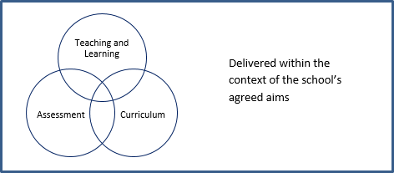

The aims of RSE for our pupils are to:

- support their health and well-being.

- develop healthy, safe and fulfilling relationships of all kinds, including those with family and friends, and in time, romantic and sexual relationships.

- navigate and make sense of how relationships, sex, gender and sexuality shape their own and other people’s identities and lives.

- understand and support their rights and those of others to enjoy equitable, safe, healthy and fulfilling relationships throughout their lives and advocate for these.

1.5 Whilst striving to achieve these aims, we will embed a clear values and rights framework,
taking guidance from the Children’s Commissioner’s published guide for schools

The Right Way: A Children’s Rights Approach for Education in Wales.

Statutory requirements

This policy follows the statutory guidance published under section 71 of the Curriculum and Assessment (Wales) Act 2021 (the Act); it is designed to assist those responsible under the Act to design RSE as part of the curriculum.

Aspects of RSE are infused within the day-to-day operation of our school; incorporated.
through the curriculum, both in content included in subject schemes of work and through other planned learning opportunities in the school. They are captured in our written aims and expressed in the ethos and behaviour of everyone.

In our School, we must ensure that every registered pupil who is provided with secondary education at the school is provided with Relationships and Sexuality Education

Policy development

The RSE policy has been developed in consultation with staff. The consultation and policy development process involved the following steps:

Review – The Senior Headteacher reviewed all relevant information, including but not limited to, relevant national and local guidance.

The policy is in accordance with statutory guidance, published under section 71 of the Curriculum and Assessment (Wales) Act 2021 (the Act)

Staff consultation – school staff were given the opportunity to review the policy and make recommendations.

Ratification – once amendments were made, the policy was shared with the Education Director/Regional Head Teacher and ratified.
Policy review – this policy will be reviewed in September 2025

Purpose

Helping learners to form and maintain a range of relationships, all based on mutual trust and respect, is the foundation of RSE.

Developing an understanding of sexuality with an emphasis on rights, health, equality, and equity. Empowering learners to understand themselves, take responsibility for their own decisions and behaviors, and form relationships that are fully inclusive, reflecting diversity and promoting respect.

Supporting learners to navigate and make sense of relationships, sex, gender, and sexuality.
RSE is objective, critical, and pluralistic as to its content and manner of teaching. We do not seek to indoctrinate to a particular view but instead provide a range of views on a given subject.

Where questions of values arise, we will present learners with different perspectives on a range of views on issues commonly held within society.

Curriculum

Our curriculum is set out in Appendix 1, but we may need to adapt this as and when necessary.

We have developed the curriculum in consultation with the staff, taking into account the age, needs and feelings of pupils via MDT’s, PEP’s, EHCP, IDP, questionnaires. If pupils ask questions outside the scope of this policy, teachers will respond in an appropriate manner, so they are fully informed and do not seek answers online.

The RSE and PSE curriculum complements the whole school approach to pupil well-being and links to the school’s other policies such as Behaviour, Anti Bullying and Safeguarding Policies.

Delivery of RSE

RSE is taught alongside the PSE curriculum. The PSE course is delivered to all pupils through discrete weekly lessons taught by teachers (see Appendix 1). Elements of the programme may be supported through the bringing in of additional expertise, such as outside speakers, trained health professionals, or the use of teachers with a particular interest or knowledge in a specific area.

The curriculum content is delivered in a non-judgmental and factual way which allows pupils to ask questions, either as part of a group or through anonymousness such as question boxes.

Relationships Education focuses on teaching the fundamental building blocks and characteristics of positive relationships, helping them to develop healthy, nurturing relationships of all kinds, including:

    - Families and people who care for me.
    - Respectful relationships, including caring friendships.
    - Online and media.
    - Being safe
    - Intimate and sexual relationships, including sexual health. (Age appropriate or depending on the context of students)

In addition to these discrete sessions, RSE is also embedded within the curriculum (E.g., social issues through the teaching of English Literature; Health through Biology and PE; Citizenship through History & RE). There are also centrally organised sessions which supplement the delivery in-house.

Other aspects such as families and different types of relationships are included in RSE.

  - The areas of learning for family are taught within the context of family life, taking care to ensure that there is no stigmatisation of children based on their home circumstances (families can include single parent families, LGBTQ+ parents, families headed by grandparents, adoptive parents, foster parents/carers amongst other structures), along with reflecting sensitively that some children may have a different structure of support around them (for example: looked after children or young carers).

  - Additional aspects can be covered in assemblies and form/tutor time activities. The religious background of all pupils will be considered, and activities planned accordingly to ensure all content is handled sensitively and appropriately.

  - For more information about our RSE curriculum, see Appendices 1 and 2.

Roles and responsibilities

The Education Director/Regional Head Teacher

The Education Director and Regional Head Teacher will approve the RSE policy and hold the Senior Headteacher to account for its implementation.

The Education Director and Regional Head Teacher will ensure that:
  - all pupils make progress in achieving the expected educational outcomes.
  - The subjects are well led, effectively managed and well planned.
  - The quality of provision is subject to regular and effective self-evaluation.
  - Teaching is delivered in ways that are accessible to all pupils with ALN.
  - Clear information is provided for parents/ carers on the subject content,
offering them the opportunity to engage with learning and teaching in RSE.
  - the subjects are resourced, staffed, and timetabled in a way that ensures that
the school can fulfil its legal obligations.

The Senior Headteacher

The Senior Headteacher is responsible for ensuring that RSE is taught consistently across the school.

Leadership and Overview

The staff who have the main responsibility for the overview and yearly evaluation of this policy are the Senior Headteacher, Education Director and Regional Head Teacher. However, all staff are responsible for ensuring this policy is implemented and acted on.

When evaluating the use and impact of this policy, the Senior Headteacher will evaluate the extent tto which there is evidence of a curriculum which:
  - Fulfils the aims of the school.
  - Embeds aspiration, attributes, and the expectation to achieve high standards and high rates of progress; and
  - Provides engagement and excitement for learning.

Staff

Staff are responsible for:
- Delivering RSE in a sensitive way.
- Modelling positive attitudes to RSE.
- Monitoring progress.
- Responding to the needs of individual pupils and their developmental stage.

Pupils

Pupils are expected to engage fully in RSE and, when discussing issues related to RSE, treat others with respect and sensitivity.

Pupils with Additional Learning Needs

Our curriculum is inclusive and our RSE and Health Education is accessible for all pupils.

High quality teaching that is differentiated and personalised will be the starting point to ensure accessibility for all students.

The school is aware that some pupils are more vulnerable to exploitation, bullying and other issues due to the nature of their ALN. Relationships Education and RSE can also be particularly important subjects for some pupils; for example, those with Social, Emotional and Mental Health needs or learning disabilities. Such factors will be taken into consideration in designing and teaching these subjects.

Training

Staff are trained in the delivery of RSE as part of their professional development.

External visitors might be invited into the school to provide support and training to staff teaching RSE and to review the teaching resources.

Monitoring arrangements

The delivery of RSE is monitored by the Senior Headteacher, Education Director, Regional Head
Teacher through:
- Line Management
- Learning walks
- Observations
- Pupil feedback

Pupils’ development in RSE is monitored by Senior Headteacher and teachers/Instructors as part
of our internal assessment systems.

This policy will be reviewed, annually, by the Senior Headteacher/Education Director and
Regional Head Teacher.

Appendix 1 Relationships and Sexuality Education Curriculum Map
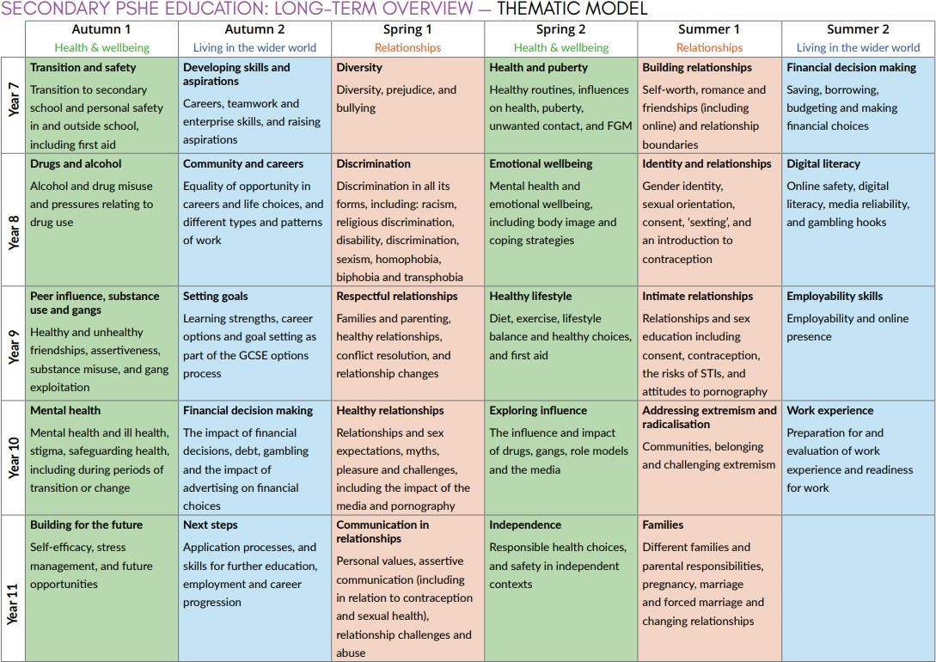

Appendix 2: By the end of secondary school, pupils should know:

TOPIC | PUPILS SHOULD KNOW
Families | - That there are different types of committed, stable relationships  - How these relationships might contribute to human happiness and their importance for bringing up children  - What marriage is, including their legal status e.g. that marriage carries legal rights and protections not available to couples who are cohabiting or who have married, for example, in an unregistered religious ceremony  - Why marriage is an important relationship choice for many couples and why it must be freely entered into  - The characteristics and legal status of other types of long-term relationships  - The roles and responsibilities of parents with respect to raising of children, including the characteristics of successful parenting  - How to: determine whether other children, adults or sources of information are trustworthy: judge when a family, friend, intimate or other relationship is unsafe (and to recognise this in others’ relationships); and, how to seek help or advice, including reporting concerns about others, if needed
Respectful relationships, including friendships | - The characteristics of positive and healthy friendships (in all contexts, including online) including trust, respect, honesty, kindness, generosity, boundaries, privacy, consent and the management of conflict, reconciliation and ending relationships. This includes different (non-sexual) types of relationship  - Practical steps they can take in a range of different contexts to improve or support respectful relationships.  - How stereotypes, in particular stereotypes based on sex, gender, race, religion, sexual orientation or disability, can cause damage (e.g., how they might normalise non-consensual behaviour or encourage prejudice)  - That in school and in wider society they can expect to be treated with respect by others, and that in turn they should show due respect to others, including people in positions of authority and due tolerance of other people’s beliefs.  - About different types of bullying (including cyberbullying), the impact of bullying, responsibilities of bystanders to report bullying and how and where to get help.  - That some types of behaviour within relationships are criminal, including violent behaviour and coercive control.  - What constitutes sexual harassment and sexual violence and why these are always unacceptable?  - The legal rights and responsibilities regarding equality (particularly with reference to the protected characteristics as defined in the Equality Act 2010) and that everyone is unique and equal

TOPIC | PUPILS SHOULD KNOW
Online and media | - Their rights, responsibilities and opportunities online, including that the same expectations of behaviour apply in all contexts, including online.  - About online risks, including that any material someone provides to another has the potential to be shared online and the difficulty of removing potentially compromising material placed online.  - Not to provide material to others that they would not want shared further and not to share personal material which is sent to them.  - What to do and where to get support to report material or manage issues online  - The impact of viewing harmful content  - That specifically sexually explicit material e.g., pornography presents a distorted picture of sexual behaviours, can damage the way people see themselves in relation to others and negatively affect how they behave towards sexual partners.  - That sharing and viewing indecent images of children (including those created by children) is a criminal offence which carries severe penalties including jail.  - How information and data is generated, collected, shared, and used online
Being safe | - The concepts of, and laws relating to, sexual consent, sexual exploitation, abuse, grooming, coercion, harassment, rape, domestic abuse, forced marriage, honour-based violence and FGM, and how these can affect current and future relationships.  - How people can actively communicate and recognise consent from others, including sexual consent, and how and when consent can be withdrawn (in all contexts, including online)

TOPIC | PUPILS SHOULD KNOW
Intimate and sexual relationships, including sexual health | - How to recognise the characteristics and positive aspects of healthy one-to-one intimate relationships, which include mutual respect, consent, loyalty, trust, shared interests and outlook, sex and friendship.  - That all aspects of health can be affected by choices they make in sex and relationships, positively or negatively, e.g., physical, emotional, mental, sexual and reproductive health and wellbeing.  - The facts about reproductive health, including fertility and the potential impact of lifestyle on fertility for men and women.  - That there are a range of strategies for identifying and managing sexual pressure, including understanding peer pressure, resisting pressure, and not pressuring others.  - That they have a choice to delay sex or to enjoy intimacy without sex.  - The facts about the full range of contraceptive choices, efficacy, and options available  - The facts around pregnancy, including miscarriage.  - That there are choices in relation to pregnancy (with medically and legally accurate, impartial information on all options, including keeping the baby, adoption, abortion and where to get further help)  - How the different sexually transmitted infections (STIs), including HIV/AIDs, are transmitted, how risk can be reduced through safer sex (including through condom use) and the importance of and facts about testing.  - About the prevalence of some STIs, the impact they can have on those who contract them and key facts about treatment.  - How the use of alcohol and drugs can lead to risky sexual behaviour  - How to get further advice, including how and where to access confidential sexual and reproductive health advice and treatment

